

TABLE OF CONTENTS

- QUICK GUIDE 3

B. OTHER FUNCTIONS 4

C. COMPONENTS 8

ELEMENTS OF A CALL NUMBER 9
COMPONENT RULES 14
FILES 16
LABELS 17
FONTS 18
SPECIAL TABLES 19
GENERAL 22

QUICK GUIDE
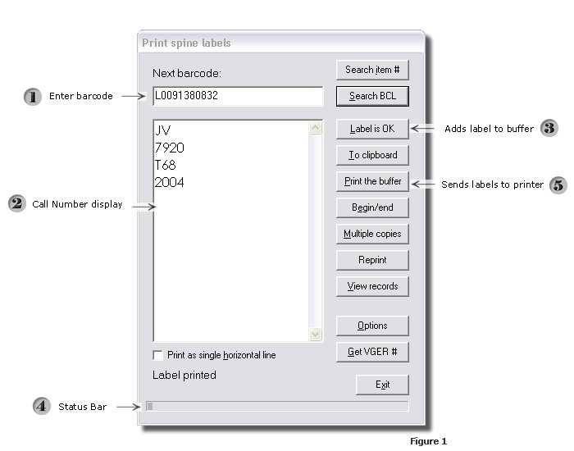

Open the Spine Label Program by clicking on the shortcut on your desktop. You can also access it by clicking on Start > All Programs >Northwestern University Library > Spine Labels.

1) Scan or Type barcode. By default, the cursor is in the “Next barcode” box.

    - If you scan the barcode, the program should automatically pull up the call number. This is dependent on whether the record has loaded into Voyager.

    - If you type the barcode, you must hit the Enter button or click on the “Search BCL” (search barcode label) button. You can also press ALT + S if you prefer.

Important: The program is case-sensitive so make sure the Caps Lock is de-activated. Also, the Voyager Cataloging Client doesn’t have to be running in order for the spine label program to work.

- Call Number Display

After searching by barcode, the call number appears in the Call Number display window.

If there’s no barcode to enter, the Call Number display window can be treated as a text processor. You can add, modify and delete text, as well as, copy, cut and paste text using CTRL + C, CTRL + X, and CTRL +V. This can be very useful when the barcode does not pull up a call number.

- Send label to buffer

Click on “Label is OK,” once you’ve verified the call number is correct. You can also assign a function key such as, F12, to perform the same function. To change this key, refer to the Files tab in the Options panel (see page 16).

A dialog box (see Fig.2) which looks roughly like a sheet of labels will appear each time the program is ready to start a new page. The squares represent the 48 labels on a single sheet. The program prompts you to choose the location of the first label at which it should start printing. Once you’ve chosen a square, press the OK button.
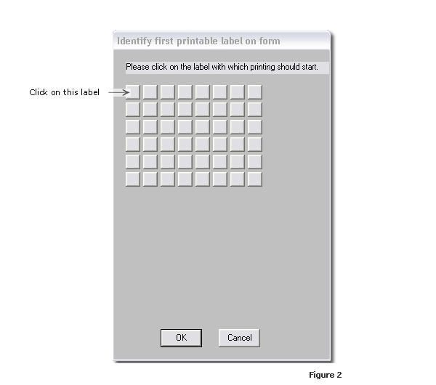

The program stores the label(s) in a buffer. Once all 48 labels have been verified and OK’d, the buffer will release the whole buffer at once and will print automatically.

Important: The program has no print preview. The call number can’t be edited once it’s been sent to the buffer.

- Status Bar

If you’re not sure how full your current sheet is, refer to the status bar at the bottom of the main window (see Fig. 1). The squares represent labels that have been stored in the buffer.

The status bar is re-set when the print buffer is released to the printer.

- Print the labels

You can print the labels at any time during a session by clicking on the “Print the Buffer” button.

There’s also a “Reprint” button. Pressing this option allows you to print another copy of the sheet of labels printed most recently.

OTHER FUNCTIONS

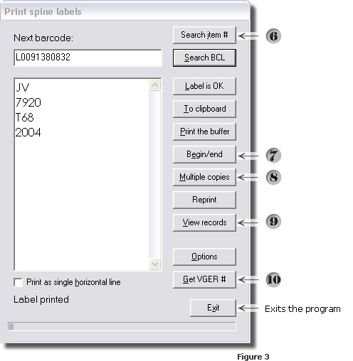

The spine label program provides the user with other functions as well. Although they’re not as highly used as those covered in the Quick Guide, the user can utilize any of the following tools from the main window.

- If the user knows the Voyager item record number, this can be entered in the “Next barcode” window instead of a barcode. The call number will be retrieved much the same way and will display in the window below.
- This button will generate a series of labels for a set of volumes. If you have 48 volumes of a particular title, the program will generate all 48 labels in one touch of a button.

- With the call number already displayed, click on the “Begin/End” button and the following dialog box will appear. Indicate how many subsequent volumes you need labeled.
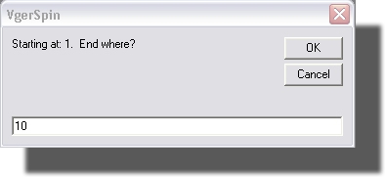 Figure 4

- You can also generate multiple identical copies of a label by indicating how many labels you want generated.

  - The following window will display prompting you how many duplicate labels you want generated.

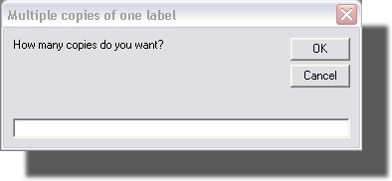Figure 5
- This button enables you to inspect bibliographic, holdings & item records without logging on to the Voyager Cataloging client. The program will retrieve these records for the call number in the display window.

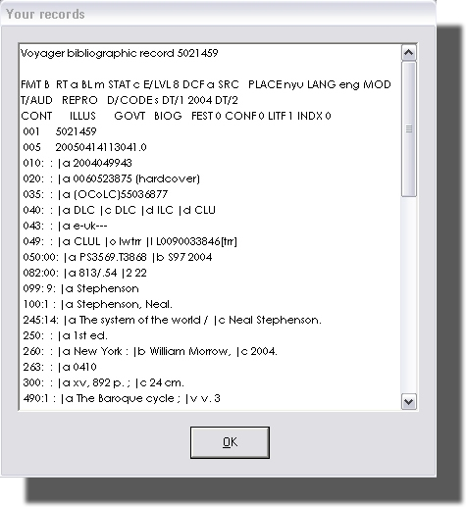Figure 6

- If you are logged on to Voyager and have a record up, you can generate a label by clicking on this button.
COMPONENTS

The Components panel can be accessed by clicking on the Options button in the main window.
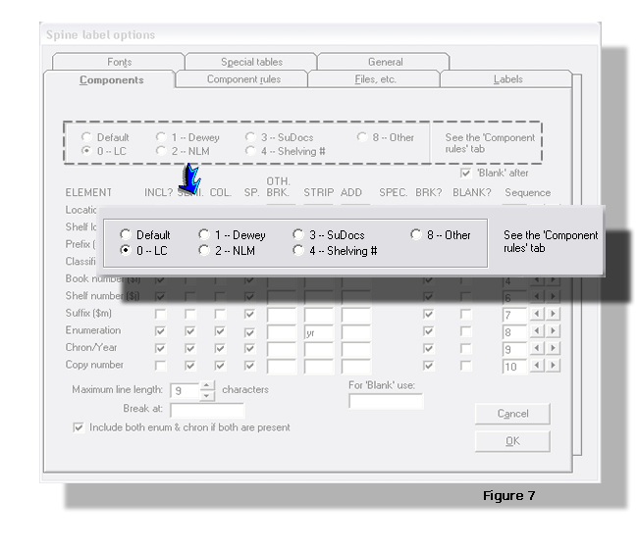
The Components tab is what Gary Strawn calls the “heart of the [spine label] program.” How the call number displays in the main window will depend largely on how the settings in this tab are configured.

In the figure above, you can set up the program to work with different call number types. The selections reflect the many different call number classifications that a library may use, such as, LC, NLM, and Dewey & so on. The number before each type corresponds to the first indicator in an 852 field of a Voyager holdings record. For example, if the first indicator is a “0”, then it’s an LC call number.

When you first open the Components tab, the “Default” radio button will always be selected. Make sure you choose the correct radio button for the call number type you’re working on.

The “See the ‘Components rules’ tab” only applies to LC call number classifications and will be grayed out if you choose other call number types.

ELEMENTS OF A CALL NUMBER
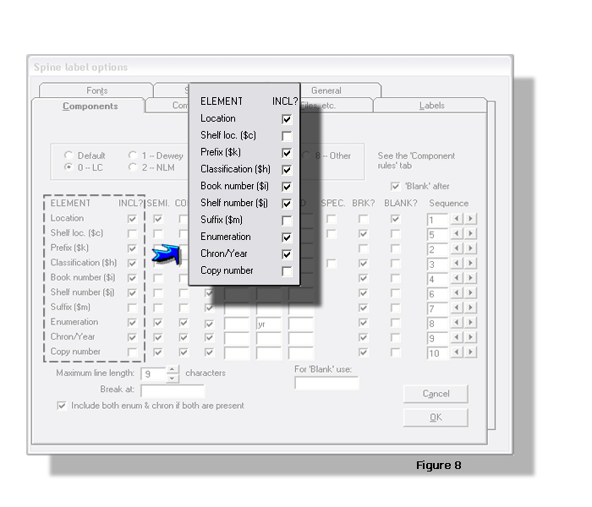
The first thing you need to decide is what elements of a call number need to be displayed and/or printed. The program provides selections under the heading “Element.” To the right is a column of boxes under the header “INCL?” Basically what it’s asking is if you’d like to include any of the elements, place a check mark in the corresponding boxes.

- Location
The spine label name of a branch location has been predefined in the Voyager System Administration client. The client controls how the branch name displays in the spine label program. (For future changes, please use the location change form at http://libteams/lis/Voyager/Forms/AllItems.htm.)

- Prefix ($k)
You may want to check this box off because this is where oversized information
is retrieved. Also, this is used for non-print materials, such as, CD-ROMs, DVDs, etc.

- Classification ($h) & Book Number ($i)
Check these boxes off because these are where the call numbers are taken from.
- Enumeration
If you are working with multi-volume sets, the volume number is taken from the “Enum” field of an item record in Voyager. It’s probably best to check this off as well.

- Shelf loc ($c), Shelf number ($j), & Suffix ($m)
These elements are not used in Voyager. It doesn’t matter whether you check the boxes off or not.

- Copy Number
Voyager does assign copy numbers to item records but the UCLA Library has
stopped utilizing this element in its call number labeling system. The box should remain unchecked.
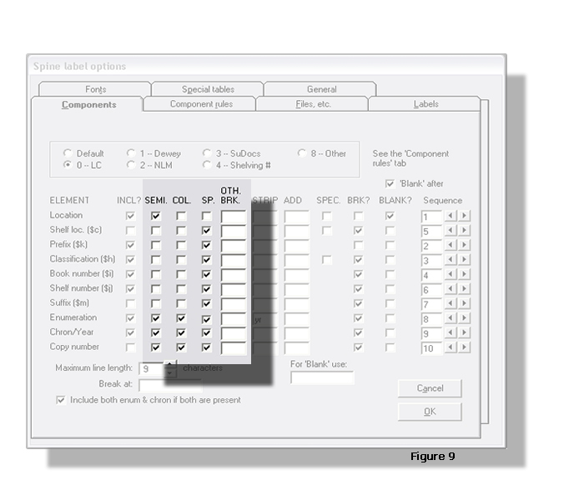

The next four columns highlighted in the above illustration will help you decide where to make a new line in a call number. An element can be broken at each semicolon, at each colon and/or at each space by checking off the boxes underneath the headers SEMI., COL. & SP.

UCLA Library does not use semicolons or colons in its call number system so these can be disregarded. You can leave them checked or unchecked. It does not matter.

Spaces, however, are utilized so check these boxes off accordingly. If there are other punctuations used in a call number, specify the punctuation by typing it in the appropriate box (es) under the header OTH. BRK.

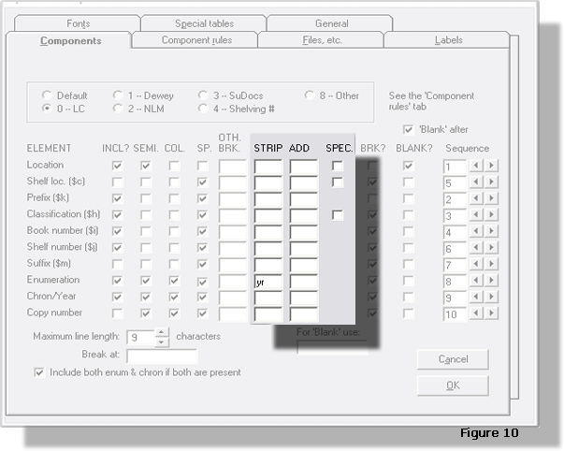

The next two columns will help you configure the program to strip or add punctuations in a call number. If you wish to remove a punctuation or character from a call number, type it in the boxes for each element under the header STRIP.

In the above example, “yr” is entered for Enumeration. Acquisitions staff will often use “yr.” plus a four-digit year in an item record. However, “yr.” is never used in a label when it’s printed.

If you’d like to add a punctuation or character to an element, type it in the boxes under the header ADD.

Disregard the SPEC. column because it will not be used for UCLA Library call numbers.

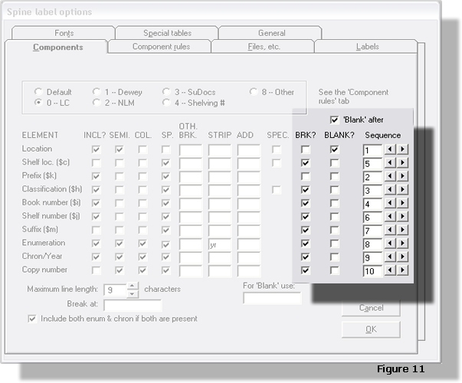

If you’d like to start a new line after an element, make sure to place a checkmark in the appropriate box under the header BRK? This will be true for most of the elements you’ve included.

For example, if you’d like the two elements (classification and book number) displayed on separate lines, check off the box for “Classification ($h)” as shown above. On the other hand, you may want to leave the “Prefix ($k)” unchecked so that an asterisk (*) will remain on the same line as the classification for oversized materials.

The next column, “BLANK?” refers to whether you want to include a blank line after or before an element. Almost all of UCLA Library’s call numbers will include a blank line after the branch location. Place a checkmark in the box for Location, as well as. the “Blank after” box. If the “Blank after” box is unchecked, the blank will appear before the branch location.

Another important thing to remember is if the “BRK?” and “BLANK?” boxes are checked off for “Location”, the resulting display will be two blank lines after the branch location. So, remember to uncheck the “BRK?” box for this element.

The last column, “Sequence,” refers to the order in which the elements will appear on a call number label. For example, Location is usually the first element in a call number. To do this, assign a “1” in the appropriate box. To increase or decrease the number, click on the appropriate arrow buttons to the right of each box.

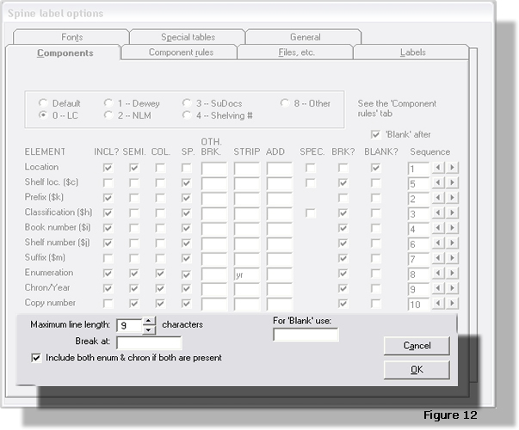

The “Maximum line length” box refers to the maximum number of characters allowed on a single line. This can be controlled by clicking on the up (increase) or down (decrease) arrows.

Disregard the “Break at” box. (This box contains punctuations which the program should break lines that are longer than the length given in the “Maximum line length” box.)

The “Include both enum & chron if both are present” box will print both item record fields if the box is checked off. This may seem redundant if you’ve already checked off “Enumeration” & “Chron/Year” under the “INCL?” column.

Disregard the “For ‘Blank’ use” box. (This box can be used to instruct the program to print punctuations or characters instead of a blank line. This should only work if you have a “BRK?” box checked off for an element.)

Finally, make sure you click “OK” to retain the configuration or else click on “Cancel”.
COMPONENT RULES

This tab is only available for LC Classification call numbers. Click on the “0-LC” radio button in the Components tab to activate this tab. The following examples and instructions are taken from Gary Strawn’s “Getting Started with the spine label program” as it clearly describes how this function works.

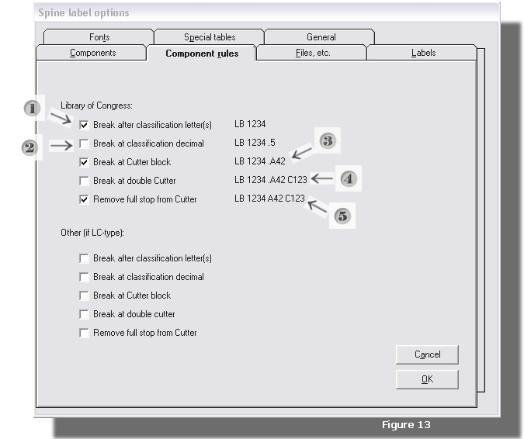

The program can force line breaks at four different points in an 852 subfield $h even if the classification number doesn’t contain blanks or other separator characters.

- For a line break between the classification letters and classification number, check off the box shown in the illustration above as “1”. The desired result for a classification number with

$hLB1234

will appear as:

LB
1234

- For a line break between the whole number portion of the classification number and any decimal portion of the number, check off the box shown in the illustration above as “2”. The desired result for a classification number with

$hLB1234.5

will appear as:

LB
1234
.5

- For a line break before any Cutter number (prefixed by a full stop) that appears
in an 852 subfield $h, check off the box shown in the illustration above as “3”. The desired result for a classification number with

$hPS2345.A23

will appear as:

PS
2345
.A23

- For a line break between the second of two Cutter numbers that appear in subfield $h, check off the box shown in the illustration above as “4”. The desired result for a classification number with

$hLB1234.A23C42

will appear as:

LB
1234
.A23
C42

- To remove the period (or full stop) that appear before a Cutter, check off the box
shown in the illustration above as “5”.

FILES

To access “Files”, click on Options in the main window, then Files.

The Files window works in conjunction with the installation and configuration of the Oracle ODBC driver. It is important that an LIT representative assist you when filling out the items below.

The LIT representative should refer to Gary Strawn’s “Getting Started with the spine label print program” document when filling out the following items: Data source, Table prefix, User ID, Password and Vger version.

As of January 2005, the “Files” configuration should appear as follows:

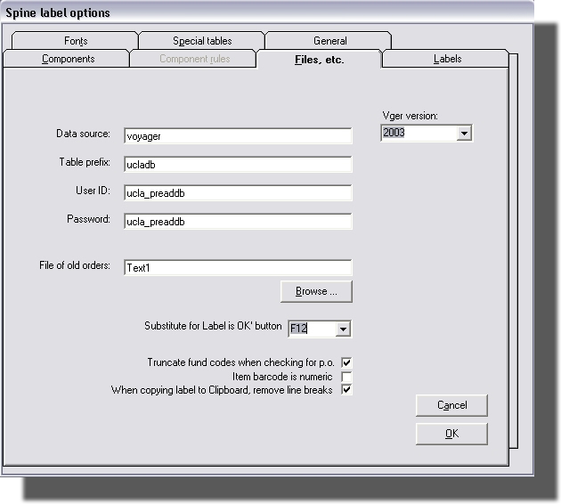Figure 14

Disregard “File of old orders” and “Truncate fund codes when checking for p.o.” The former is only used at Northwestern Library. The latter will not be used by the label marker at YRL Physical Processing.

Of particular importance to the label marker is the “Substitute for Label is OK” button. Instead of using the mouse to click the Label is Ok button in the main window; the user can use a keystroke equivalent, in this case, F12. Any function key can be utilized for this specific purpose just as long as it is selected in this window.

Since most of the barcodes used at UCLA are alpha-numeric, leave the “Item barcode is numeric” unchecked. This is very important because the program will not be able to recognize a barcode, such as, one that begins with L 000 and others like it, if this option is checked.

“When copying label to Clipboard, remove line breaks” Leave this item checked.

LABELS

The following window can be accessed by clicking on Options in the main window, then the Labels tab.

Use the configuration below as shown for Brodart Laser Spine Labels that have the following specifications:

Sheet dimension: 11” x 8 ½”
Number of labels per sheet: 48 labels
Label dimension: 1 2/3” x 1”

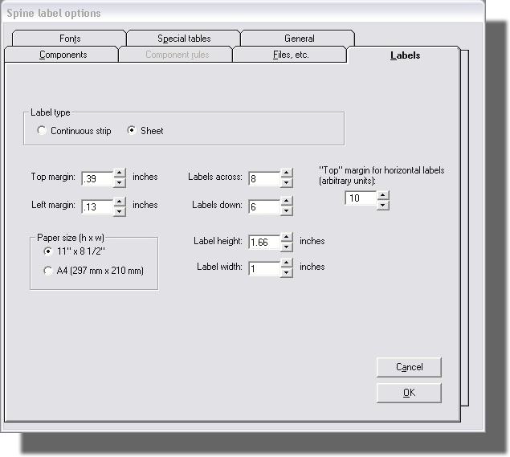Figure 15

Label type: refers to a continuous strip of labels (e.g., SeLin) or a sheet of laser printer labels

Top/Left Margin: refers to the label margin (not the margin of the sheet)

Labels Across/ Down: refers to the number of labels on the sheet

Paper size (h x w): refers to the dimensions of the sheet

Label Height/Width: refers to the dimensions of a label on the sheet

Changing the font and/or font size will affect how the call number displays on the label.
The top and left margins may have to be re-configured to achieve to desired results. The
preferred settings are shown above in Figure 1.

(Unless the “horizontal labels” option will be utilized, disregard the “Top” margin
for horizontal labels option)

FONTS

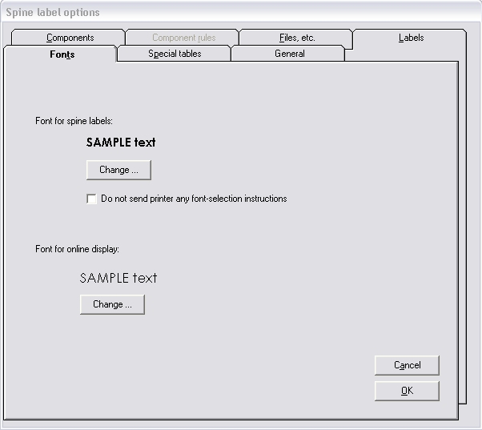 Figure 16

Use this panel to select or change the font on both the printing labels and the online display of a label.

To access this panel, click on Options in the main window, then the Fonts tab.

Click on the “Change” button to select the desired font type, style & size.

Important: The fonts cannot be changed in the middle of a session.

A wide array of fonts & font sizes can be used, but the following configuration seem to work for most call number labels generated, including YRL and most branches.

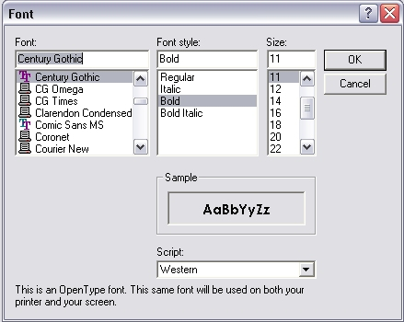 Figure 17

Helpful Hint: A different font or font size can be used for the online display. Making the font larger to make the screen display legible from a distance can be very useful.

SPECIAL TABLES

As Gary Strawn indicates in his document, “Getting Started with the spine label print program,” this tab lists auxiliary files associated with certain call number elements or with bibliographic records in general.

As of January 2005, the only button utilized by the UCLA Library is “Locations with replacement spine label option.” This button overrides branch locations, as they appear on a call number, defined in the Voyager System Administration client. It is suggested to not use this function but use the location change form at http://libteams/lis/Voyager/Forms/AllItems.htm.)

The other buttons have not been explored and may be of some use in the future.

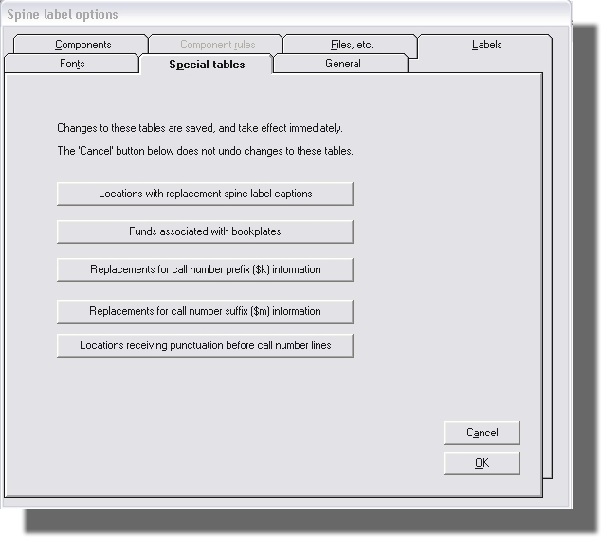 Figure 18

The locations with replacement spine label captions can be accessed by clicking on the Options button in the main window. Select the tab that reads “Special Tables.”

The “Locations with replacement spine label captions” table allows you to control how the branch name displays on the call number.

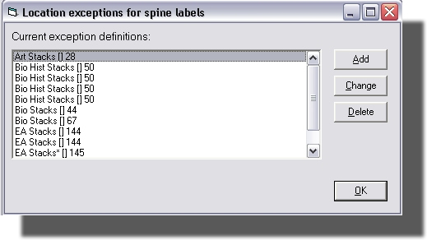 Figure 19

To define a new branch name, click on the Add button.

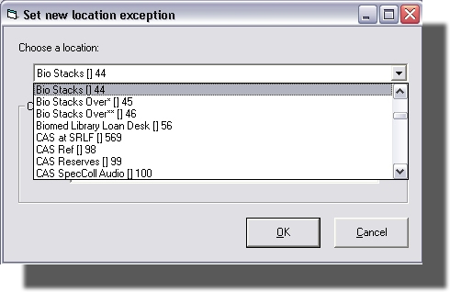 Figure 20

Choose the location by selecting or highlighting the appropriate branch from the drop-down menu. In the above example we’re using Bio Stacks. Click OK.

Then, select the second radio button “Use this spine label information instead:”

In the blank box, type in the branch name as it should appear on the call number. In our example, type Biomed. See the figure below.

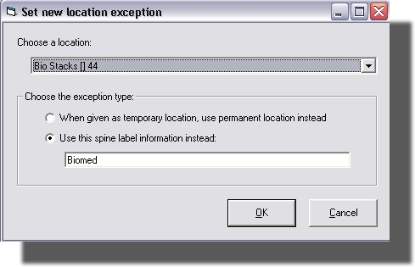 Figure 21

GENERAL

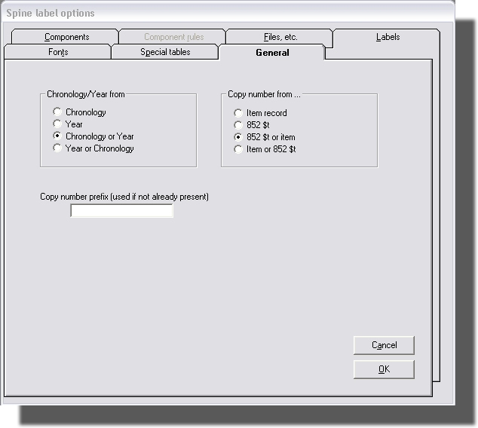 Figure 22

UCLA Library is currently not using either any of the functions covered in this tab. The following brief description is taken from Gary Strawn’s “Getting Started with the spine label print program.”

In the group titled “Chronology/Year from”, you can indicate if the spine label program should look for chronology-type information in the Chronology or Year area of the Voyager item record.

In the “Copy number from area”, you can indicate whether the program should look for the copy number in the Voyager item record or the 852 field. The selection in the illustration above shows that it can look for both.

In the “Copy number prefix” box, you can indicate any prefix that should be added to the copy number retrieved from the Voyager item or holdings record. Gary uses “c.” as an example.

